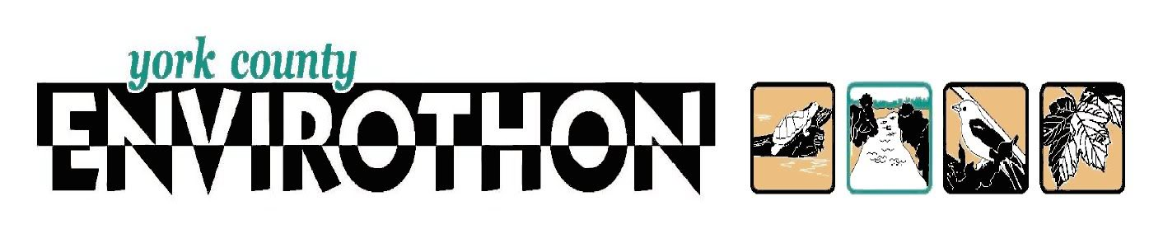Envirothon Competition: Tuesday, May 1, 2018
What is it? the largest environmental education competition in the nation
Participants: open to all 7th and 8th grade students
Meeting/Practice: Weekdays in February, March and April (day to be determined by participants; we may meet on different days in order to accommodate everyone)
3:00 – 4:15
SMS Library
Responsibilities: -- There is no cost for this program
-- Students make a commitment to specialize in one of four areas:
Forestry – Aquatics – Wildlife – Conservation in Your Life
and add to the general knowledge of the team
-- Arrange for pick up at 4:15 on practice days
-- Bring a packed lunch on the day of the competition
-- Complete and return the permission slip below
Advisors: Mrs. Fruci (francesca.fruci@sycsd.org) and Mrs. Zinn (jan.zinn@sycsd.org)
Name __________________________________ Grade ____ Homeroom ______
Has my permission to participate in the 2018 Envirothon as part of the Southern Middle School Team. I understand that this requires participation in the majority of practices (unless other arrangements have been made) and that I will see that transportation is provided on those days, with pick-up at 4:15.
Furthermore, the school has my permission to transport my child in a school district vehicle on the day of the competition.
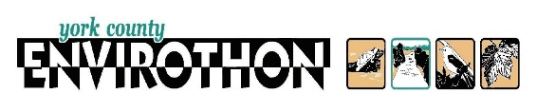
Parent/Guardian Name (printed) ____________________________________
Phone: ____________________________________
Signature ___________________________________
To help plan practices, please indicate below which meeting day(s)
are BEST, which are OKAY and which are NOT
MON: ________ TUES: ________ WED: ________ THUR: ________ FRI: _______

